Throughout the ages, Africa has been a continent of great civilizations, colonialism, exploration and turmoil. No other continent has such a rich cultural history and significance in the history of mankind. Once the birthplace of some of the largest and most influential civilizations the world has ever seen, Africa was colonized, exploited and sent spiraling into the ruin of economic and social chaos. The age of discovery brought the Dutch, English, German, and French explorers that brought back evidence of successful trading and new shipping routes it was not long until their home countries had a vested interest in “The Dark Continent”. Resources and trade goods were plentiful in the varying climate and terrain that Africa had to offer and many countries looked to Africa as a cheap and abundant supplier of natural resources. The Dutch capitalized on the convenient and accessible ports and long coastlines that Africa had to offer. These countries set up colonies wherever it was most convenient for the exploitation of resources and a plentiful workforce which they found in the African natives.
Soon, nations from far away had colonized much of the continent, with little to no governance by the natives of the land. The colonizing powers decided it would be best to divide the continent into a multitude of nations which they would govern as their colonies. A disregard for cultural and ethnic boundaries caused the partitioning of Africa to become a source of contention for generations to come. Little to no effort was made to draw borders along preexisting ethnic regions that had existed for centuries. Oftentimes competing tribes were included in the same country or some ethnicities were split in half by the new borders. When independence began coming to the African nations in the late eighteenth and the nineteenth centuries, power and control was handed over suddenly and without preparation to the Native people. In areas with tense ethnic relations matters only got worse when one ethnicity was put in power and the others had no place in the government. Historical events such as this have set the stage for a long period of civil war and ethnic genocide.
Not only have the people of Africa suffered, but their ability to support developing nations and exponentially increasing populations have also taken a turn for the worst. For survival there are three things that humans need above all else: food, shelter and water. Water is probably the single most important commodity required for survival because of the role it plays in the provision of food. The ability to acquire or produce food has been one of the primary reasons a civilization is able to sustain itself and remain intact. In ancient times, the natives of Africa were required to live off of the land and limited resources. Water and rich soils are scarce in much of the continent and labor and knowledge of agricultural practices are necessary in order to be productive.
Recently, on a trip to Kenya I realized the import role that agriculture plays in the lives of Kenyans and in the lives of Africans in general. A significant portion of Kenya’s GDP is tied to agricultural and it provides a staggering seventy-five percent of Kenya’s labor force works in the agriculture sector. Kenya relies on the exportation of agricultural products such as tea and coffee in order to elicit a meager profit from its agricultural exports. More important than a vibrant export economy is the ability of a country to feed its own citizens. Malnutrition is a widespread issue throughout Africa. Many children and adults alike are incapable of producing enough food to adequately supply their own needs. Unlike many parts of Africa, Kenya has a climate which is suitable for a very diverse and stable crop structure.
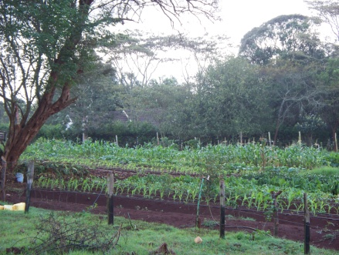
Arriving at Eshel Gardens late on December 11, 2010 we were unable to view any of the sights due to a lack of time. The entire group went to bed shortly after arrival and a light snack. The following morning, December 12 we toured the established farming facilities that Eshel Gardens was currently trying to facilitate. Kenya was currently beginning its dry season so a lot of the crops were ready to be harvested or had been harvested prior to our trip. Eshel Gardens had built a greenhouse which stood about 30 feet tall, 90 feet long and 50 feet wide. The greenhouse was built In order to produce a large number and variety of crops year-round. Green peppers and some summer melons were two of the crops currently growing in the green house. Unfortunately, as is the case for many Kenyan crops, the melons were fighting off species of fly which fed on the leaves of the plant. Outside of the greenhouse, corn, lettuce and quite a few other types of vegetable had recently been harvested.
The Kenyan climate is somewhat ideal for a large number of crops. Some of the country has fairly fertile soils suitable for the production of crops. However, many parts of the country are considered arid and require a large amount of water both for municipal and agricultural use. In certain areas of the country there is a sever lack of nutrition available in the soil. In these arid sections of the country there is a big concern over how much water agriculture consumes. With a diminishing supply and susceptibility to drought, many Kenyans have reason for and concern. Recently within the agricultural industry, there has been a large push to become more efficient with their use of water. New innovations in agriculture and scientific achievement have made more efficient crops a reality in this developing country.
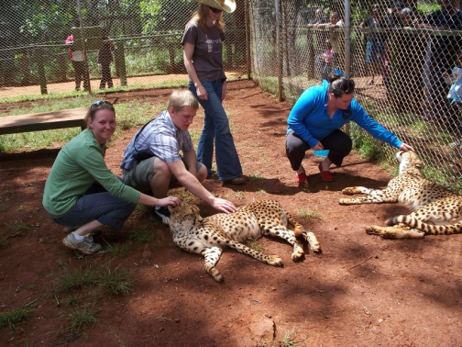
Our next destination was the Animal Orphanage, located in the city of Nairobi. We saw a lot of the animals we would expect to see while on our safari. The animals were being kept in captivity in order to rehabilitate them after devastating situations. We did get to pet cheetahs but unfortunately we are quickly discovering all about the hidden costs associated with being tourists. When we finished up here we waited around for the rest of our group. Waiting for the group soon became a common trend anywhere we went. We decided, since it was Sunday, that we would like to visit the Massai Mari Market to visit and buy souvenirs to take back with us. This was a learning experience for everyone except Emmanuel, our guide, of course. All group members learned the hard way how to barter with the locals for a decent price. The prices we were offered typically ran about three times what we should have paid, but this is part of traveling I suppose. We always seemed to spend much more time then need be at any given place. Sometimes large groups can be difficult to travel in because simple tasks are slowed down. Our trip to the grocery store took thirty minutes, when it should have been a five minute trip.
One thing that took some real getting use to was the food. It mostly was unprocessed food, which is much better for you but takes adjustment. One type of food that was always at meals was a flat bread that was sort of like a tortilla but a little sweeter. Fruits and vegetables were very common at all meals. A lack of meat in the diet was what surprised me the most. In the United States animal products make up a significant portion of our diet, however in Kenya meat was not readily available as a food product. Crops such as local fruits become popular due to their abundance and price. Globally, food prices are at an all time high, even when adjusted for inflation. Developing nations like Kenya have insufficient economic funds to spend on food products or elaborate meals. To the average American a Kenyan diet might seem vegetarian at first due to a lack of animal products. In Kenya animals are often worth more to a family alive rather than slaughtered for the meat. One milk cow and one chicken can produce milk and eggs everyday rather than meat for a limited period of time.
A significant issue that has risen to the forefront in the late twentieth and early twenty-first century has been the global focus on environmental stewardship. Developing nations tend to have a very large environmental footprint and Kenya is no exception. While other countries are experiencing problems with industrial and manufacturing pollution, there are other concerns plaguing the citizens of Kenya. Deforestation is a major issue in many parts of Kenya. Trees are vital to the ecosystem and health of the land. Forests provide soil stability, habitat for wildlife, shade to smaller plants and return oxygen back to the air in place of carbon dioxide. Acres of forest are decimated annually to make room for single crop agricultural operations. Forests are replaced by expansive fields and crops. Without proper crop rotation and a lack of native species the soils often become infertile and unstable. Unstable soils are susceptible to erosion damage. When erosion occurs, the soil sediment is carried downstream and deposited into major rivers or tributaries, often clogging their flow. Commercial fertilizers and pesticides like the ones typically used in the United States can contain expensive and damaging chemicals. Due to the lack of nutrients in the soil, fertilizer use has become more widespread in the recent decades. Kenyans have begun learning and implementing natural fertilizing techniques to reduce the amount of waste and expense. Compost and livestock waste have prevailed as the two leading techniques. Both processes reduce waste buildup by using nature to break down natural material into a substance with high nutritional value.
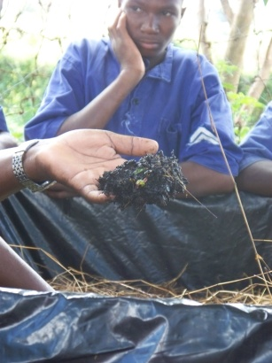
While we were still in the Nairobi area, we visited a few self sustaining farms. The first was a prison for young boys called Resources Oriented Development Initiatives (RODI). The purpose of RODI was to help young boys that were in trouble with the law better their lives through agriculture. The boys had a choice of going to RODI or going to prison. The inmates were only allowed to stay at RODI for four months before they were required to leave the facility. The main goal of RODI was to help promote and encourage the use of alternative forms of agriculture for farmers who were unable to utilize the more technological advanced agriculture methods implemented on commercial farms. They also wanted to encourage the boys to introduce these new techniques to the surrounding villages and communities in hopes of creating a more self-sustaining community. RODI also focused on trying to use more environmental friendly techniques such as natural fertilizers, pest control, mechanization and new irrigation techniques.
Inmates at RODI learn how to make their own liquid fertilizer and compost. The picture to the right shows the compost they produced. Much of the compost was produced using a mixture of soil and plant waste which was then broken down and processed by earthworms. They then pass excess amounts of water through the soil to pull any extra nutrients from the compost to add to the plants and seeds. Another method for creating their own fertilizer was to soak manure from the rabbits they raised in water. The liquid solution that was produced could then be used as a liquid fertilizer and applied directly to their crops. They raised several species of low maintenance livestock, predominantly rabbits and goats. The rabbits were used for the manure and for their meat. Rabbits require very little monetary investment and reproduce at a rate that makes their populations easily sustainable. The goats were raised for their milk; the milk had been proven to help increase the immune systems of people infected with AIDs. They also learned to collect seed to allow for a crop the following year, this not only applied to crops but to animals as well. They learned to grow crops that were not the norm of the area to enhance the diversity of the crops, which would then increase the demand for their crops. Introducing new crops and crop rotations to the area helped to increase production and revitalize the nutrients in the soil
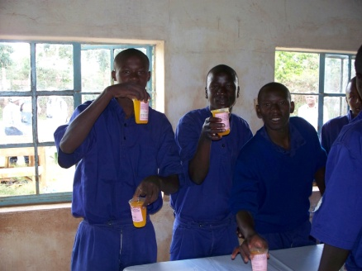
RODI also taught the boys to produce different types of produce that they could sell at local markets. All of the produce was from products they were raising at the institution. They were taught to make liquid detergent, shampoo, disinfectants, juice, yogurt, and other types of processed foods. The boys were also taught to live on their own, to cook, clean and maintain their own living spaces. These efforts were directed at helping the inmates develop more independence and less reliance on others. Our touring group needed to wait for Mike and Erin to catch up with us before we continued on to another self-sustaining farm in the area.
Our next stop was G-BIACK which stands for Grow Bio-intensive Agriculture Center of Kenya and was a local farm that was focused on teaching the surrounding community to become more self-reliant. G-BIACK’s goal was create a community that could thrive by utilizing new and more economically efficient methods of farming. They train, demonstrate and promote the techniques that make them a bio-intensive organization on a small scale farm. Bio-intensive agriculture is where the producer’s goal is to achieve maximum yield with the smallest amount of resources possible and with the least amount of impact. The founders of this program are both graduates of Manor House Agricultural Center located in Kitale, which will be discussed later in the paper.
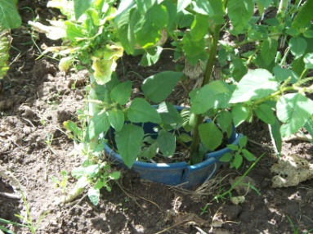
One way they are looking to improve the community is by teaching the practice of water conservation. One method they teach involves digging a hole in the middle of a garden. This hole is designed to help reduce the amount of water lost to evaporation on the surface of the soil. The amount of water lost to evaporation is proportional to the amount of water surface exposed to the air and sun. With a hole the majority of the water is not exposed, unlike surface watering techniques which spread a thin layer of water over a large area. This technique thereby reduces the amount of water lost to evaporation. The water is leached into the soil through osmosis and reaches the roots of the plants more efficiently. This practice was only intended for small gardens that would only produce crops on a small scale. G-BIAK focused on informing people of the community to learn to create their own compost, practice double-digging, close placement of plants, crop rotation, companion planting, collecting seeds, nutritionally efficient crop production, and creating a whole farm system. Like RODI inmates, they also made their own fertilizer by soaking manure in water. An interesting method they utilized for creating compost was by layering dirt, leftover crop waste and leaves, then watering every layer as they built up the compost. A significant amount of water was consumed in the production of this compost but the end results were worth it.
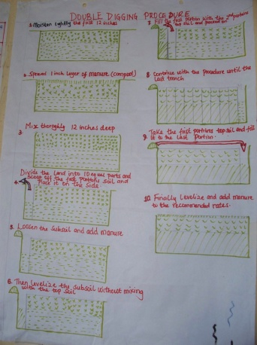
Double Digging is a growing technique utilized by numerous small farms in Kenya. The primary concept was initially based on the simple idea of rotating soil from top to bottom. Soil rotation helps to loosen the sub soil and enable maximum root growth and penetration. Loosening the soils also helps to aerate the soil and increasing the soil’s permeability making it easier for water to travel into the subsoil layers. The double digging process consists of ten simple steps, which are as follows: lightly moisten the soil and then spread compost or manure evenly on top of the soil approximately one inch thick, this fertilizer compound is then mixed down into the top twelve inches of soil. Next, divide the planting area into one foot wide sections all of the way down the row. Taking the top twelve inches of soil out of the hole allows access to sub soil layers. This also loosens the next twelve inches of soil for easy root expansion and penetration. The next one foot section would be mixed and then placed on top of the first one foot section of sub soil. This process would be continued until the entire row has been loosened and prepped for planting.
Maximizing the amount of arable land available to Kenyan farmers is a large part of expanding the agricultural productivity of farms in Africa. Kenya’s limited resources are too valuable and scarce to waste or take for granted. Bio-intensive planting is an efficient way of utilized the available arable land for maximum production. Many progressive Kenyan farmers are also beginning to practice crop rotation and are becoming educated in order to select crops with a higher nutritional value. These two concepts play into one another through the program of a Fifty Bed Unit. This was a program that hoped to teach farmers to rotate crops between beds and to also produce a diverse type of crops. In rotating crops yearly they hope to eliminate the soils from becoming unproductive due to overuse by a single variety of plants. The Fifty Bed Unit, when introduced onto one acre of land, could feed one single person for an entire year. The bed planting ratios were broke down into 50% carbon crops, 30% special root crops, and 20% income crops. The carbon crops were maize, millet, sunflowers and others that would give carbon based nutrients back to the soil providing the nutrients that are eliminated with other crops. This section of the program could also provide grains for the farmer to consume. The special root crops are crops intended for the farmer’s family to eat. The diversification of local crops benefitted the region and added to the daily nutritional intake of the family. These root crops included carrots, sweet potatoes, onions, and garlic. The final 20% were the crops intended solely for an income. Spinach, cabbage, tomatoes, and sun hemp were cash crops, ones that would bring income when taken to the market. Because these crops represent a more diverse selection than what is normally produced, they tend to fetch a higher price on the open market. All of the remaining produce had the potential to be sold for a profit if they were not needed for food purposes.
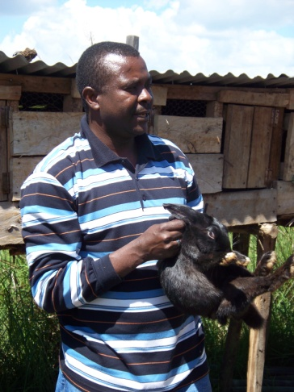
Along with all of planting they strive to teach people to diversify their farms and to be better prepared in the aspect of self-sustainability. The rabbit project is for young boys that have been orphaned because of AIDS. They teach the boys to raise rabbits. In raising the rabbits the boys are taught to care for things and it gives them more meaning to their lives. The rabbits are raised to provide meat for the boy and to provide him with a meager income. He gets a rabbit that has been bred, from which he may sell any males offspring and keep some for meat. The boy must then return one female back to G-BIACK in order to keep the project going for future generations of boys. Goats are raised for the women who have been affected by AIDS. There are many communities of women who have AIDS or have been orphaned because of AIDS. G-BIACK provides a pregnant milk goat to these communities. When the goat produces offspring, the kids are then given to another member of the group who will bring the goat back for breeding purposes. This process continues until every person in the community possesses a milk goat for themselves. It is commonly believed that the milk from goats helps people with AIDS. The milk is supposed to help boost the immune system and is more nutritious than cow’s milk. Chickens are another animal that they raise but they are not included in any type of project like the goats or rabbits are. G-BIACK demonstrates to farmers how the chickens can be utilized for their eggs and meat. Eggs and meat are both vital life-sustaining food as they provide the protein that is commonly lacking due to widespread malnutrition.
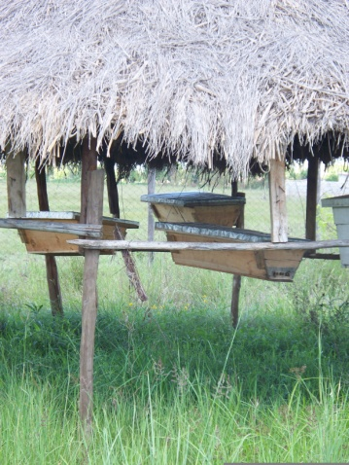
All of these animals have limited needs, they can be kept on small sections of land and also require limited amounts of feed, creating an economically viable livestock source. The goats and rabbits are both associated with community projects in order to assist people in the area to obtain the animals cheaply from the G-BIACK organization. Along with these projects they looked to teach people to raise bees for the honey, which fetches a large profit when sold at the market. There were two types of hives that they used, the traditional hives and the top bar hives or Kenyan hives. These hives are traditionally a more economical hive they are fairly easy to build.
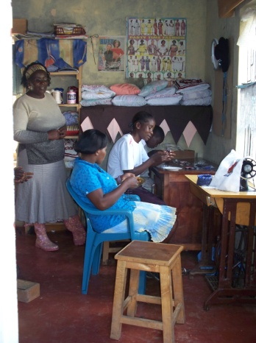
To really create a self-sustaining environment, the organization teaches people to collect seeds to plant the following season, limiting their expenses in the following year. They taught the farmers to collect the seeds from their crops. They would then test a few seeds to ensure that they were good seeds for the following year’s crop. For women, who were not really allowed to do farming, they were taught to create their own source of income from home. They learned to make clothes for their family, make necklaces, baskets, and many other simple things that could be sold for a profit at the market or utilized by their families in everyday life. The main goal of these efforts is to make sure that everyone in the family or community is providing goods that will help to benefit the entirety of the group.
In order to help advance the farming aspect of the program the G-BIACK was conducting experiments to help determine how to best utilize the land and how to plant a mixture of crop species. They were growing corn and beans together, trying to come up with a combination that was maximizing the output with reduced inputs. They had three different scenarios; first it was planting two rows of one crop then one row of the opposing crop, planting all of one crop and then all of the other, and then planting corn and beans in the same hole. Unfortunately there were many issues that worried us as to how they were getting accurate results for the experiment. First of all there was an issue of edging. They did not provide crops on the outside of the plot that would create a uniform scenario. The fact that every plant in the experiment was surrounded by a few rows of plants did not exist. If edge rows had been planted, it would reduce the wear that the plants on the outside experienced, which potentially reduced the growth and skewed the experiment’s results. Second of all, right in the middle of the entire plot was a large tree that created variance in the plot’s growing conditions. The tree not only created a shaded area reducing the heat stress of the plants but it gave back to the soil. The tree produced an excess of nitrogen that was released back into the soil and increased growth of the plants in this area of the plot that was in close proximity to the tree. It was like unequally distributing extra fertilizer on the plants to increase growth.
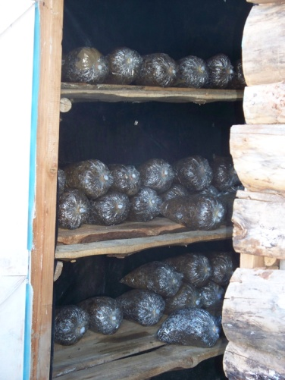
Another small self-sustaining organization we visited was called Community Sustainable Development Empowerment Program (COSDEP). This was a smaller organization that only consisted of seven members. The main goal of this organization was to help rural communities create an organic environment for farming while teaching them to be self-sustainable. One of the primary programs was to produce mushrooms that could be sold to local hotels to be put into meals for traveling guests. They specialize in growing an oyster variety of mushroom, which is a desired and economical variety of mushrooms. They create and produce all of the needed essential input products there at the farm. They must cook any soil or material that will be used in the growing of the mushroom to sterilize the material. In sterilizing the material they eliminate the risk of producing a less desirable fungus along with the mushrooms. To sterilize the soil they steam cook the material in a hot house and then bag the material. Later, they introduce mushroom spores into the material.
Another form of income that that COSDEP was implementing to surround communities was a cow-calf operation. They currently had three generations to this operation. They would breed the cow and sell a few of the offspring for an income along with selling the milk that the cows produced to create an income for the group. The cows were feed sugar cane that had been ground into a mush. Along with the cattle, they were currently raising 1200 chickens for broiler chickens. These two programs produced enough income to send the children of the group’s members to school.
Manor House was the main inspiration for the rest of the groups we visited previously. This was a program that offered a location for people to come and become students of the program. They would learn to reproduce the methods of self-sustainability and teach others. The program was located in Kitale, a little less arid region of the country but still facing water and land restraints like the country in general. The program is setup to help poor small scale farmers limit the reliability on the expensive conventional farming techniques. They hope to enable all graduates from the program with the skill and practice to replicate the designs and methods of the program on their own farms.
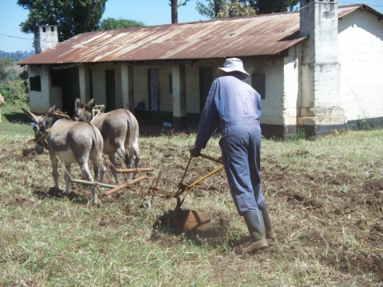
This program has initiated and sparked the idea of double digging and bio-intensive farming in the area. Along with the crops, the farm raises dairy cows, pigs, chickens, geese, rabbits and donkeys. Each and every animal had a benefit to the program but the newest development with the animals was the use of donkey. Donkeys wander the streets and roads of Kenya like stray dogs wander the slums of Mexico. There are an abundant amount of donkeys that have not been utilized to their full potential. Donkeys pull carts around for material and human transportation, but they still are a new idea when it comes to farming. Manor House has instigated the use of these beasts of burden to help with the farming. Most people were still doing all farming by hand which limited the efficiency of the land and their time in the field. With donkeys, Manor House was introducing the idea of pulling fields in half the time with the aid of donkeys. This is definitely not the most efficient way to plow a field given the world’s technological advances but for a developing country this is a great advance.
In the United States we take mechanization for granted. African agriculture still relies heavily on manual hands-on labor. Despite an abundance of livestock, very rarely are they used to assist in everyday farming. Before the industrial revolution and it can be argued until the early twentieth century the United States used very little machinery for farming however we did begin implementing draft animals into the workforce in order to increase efficiency. Developing nations tend to follow a fairly commutative set of guidelines for the logical progression of a nation.
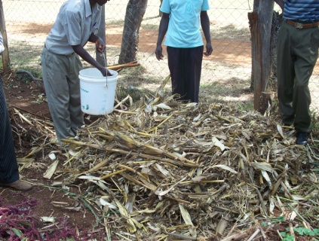
Like all the previous establishments the Manor House looked to other sources of income to help diversify their production and limit the liability and risk associated with farming. They raised bees to produce honey and wax. They demonstrated to us how to double dig, plant in an efficient pattern, and create compost. Farmers created large piles of compost from old, “useless” materials leftover from the previous harvest. They used soil, corn stalks and leafy green branches. All of these inputs, along with a large quantity of water, provided the ideal environment for microbial growth that would later produce productive soils. The compost was normally ready after approximately three days. You could tell when the pile was done decomposing when a stick placed in the center of the pile became cool to the touch.
To focus more on the actual bio-intensive part of the planting we were walked through each step that they teach each student in the program. They doubled dug the ground to loosen and aerate the soil for maximal plant growth, limit the amount of water lost, and encourage health productive soils. They had created a system for planting to increase the value of the soil. This would entail the most advantageous solution to light and water usage and creating a very limited amount of wasted space under the plants. This also limited the amount of sunlight that actually reaches the soil helping to eliminate the water loss. This planting pattern is called diagonal off set planting; they would basically plant in diagonal lines. This made the plants touch leaves and cover the soil with a shaded area. After planting the seeds the soil was covered with mulch to help reduce weed growth and water loss.
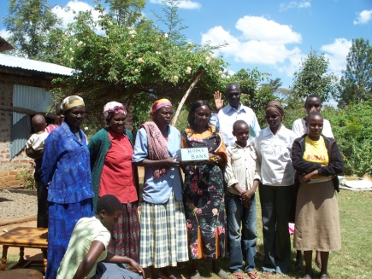
Another self-help group near Manor house was the Masedonia Self-Help Group. This was an example of an urban farm that had been influenced by the Manor House. The group was comprised of twenty different members of all ages. Each member when they were able to help with the farming was taught the techniques around their schooling. A large push for younger members of a lot of these self-sustaining groups was to have their children educated outside the home in a public school. While we were given a tour of the program one of the younger boys explained the process of creating as they called it “manure tea” of liquid fertilizer. They raised many of the same crops as the previous location but one thing that was different was one of their ways of weed reduction in the plant beds. They used old dry corn stalks to reduce both the weeds and the water loss. This was a very efficient way of reusing old bio products and eliminating weeds. Participants also collected seeds and any extra food that was not going to be consumed while fresh. They then took these things and dried them to produce a long term food supply. They took the time and effort to dry the food so that if and when the weather caused their current crops to fail they would have a source of food.
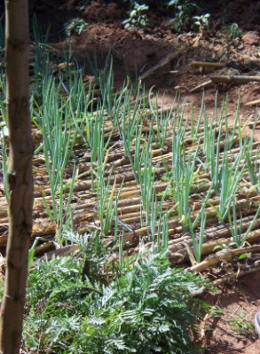
We had a chance to sit down with the different sexes of the group, women with women and men with men to discuss different ideas and questions we had for each other. We talked to the women about their daily duties and how their children were raised. We were not allotted enough time to fully discuss a lot of issues but we became to understand the general ideas governing their lives. While we were there we were the center of attention. Being white, we were a novelty to the areas children. Most of the children had not seen a Mzonga, (white person) before and were both intrigued and skeptical of us.
We continued on to another urban farm. This group of people was very disappointed because most of the crops were dead or dying because of the excessively dry season. We did get to see how land conscious they needed to be, because this was one of the smaller farms we saw the entire trip. They had very limited resources but still needed to produce and live off of what they produced. While walking into and out of this farm we were getting a lot of attention both negative and positive. The children of the area were fascinated again with both our skin color and our fancy magic picture devices. The adults on the other hand were very against our presence and were keeping a close eye on all of us.
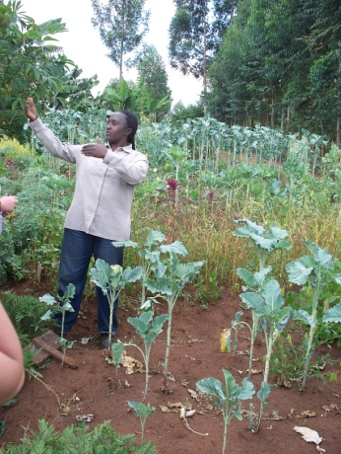
The final urban location we went to was another small organization. They also demonstrated the skills that they learned from Manor House while studying there. This group did do some agroforestry to help and demonstrate the many benefits that trees can provide to producers. This group focused mainly on water conservation and advancing their hybrid species. Even given the limited space this group was highly productive and knowledgeable about the possible advances in farming. In Kitale they were beginning to expand into agroforestry in hopes of expanding the farms.
Before we flew back to Nairobi to embark on our venture to the Maasai Mara National Park we took the time to visit organization completely dedicated to agroforestry. This facility raised seedlings into saplings and then they would sell them to farmers in the surrounding areas. Along with growing the trees they would educate the farmers about the advantages of trees not only to benefit them as a person but also to help benefit their lands. They implemented the use of trees to prevent erosion of the top soil, hedgerow intercropping, windbreaks and also to help add to the soil fertility. They also had trees for any and every service, tooth aches, headaches, sexual arousal, healing powers, food, good fortune, and many others.
The tea plantation we visited was founded in 1926 during the colonial period in Kenya. Kenya was once a British colony and that influence is still very much found on the tea plantation. This single plantation was 6,000 hectors that were divided into 12 different estates each of which then had small townships. Given today’s technological advances and the amount of income they generate the tea and coffee producers are more modernized than the producers of many other cash crops in the country. These cash crops are primarily exported bringing a higher price for them. The funding by foreign investment is what drives the tea market in Kenya, they specifically blend each type of tea exported to fit the consumers desires.
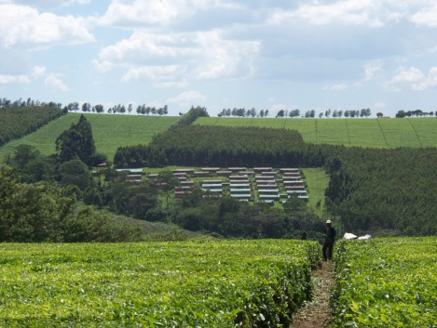
The process of producing tea has become a very scientific and mechanized operation. While many producers in Kenya rely almost entirely on hand labor there are many mechanized implements used on the tea plantation. Labor in Kenya is overall quite inexpensive and is therefore of minimal concern to large commercial operations. Trucks and delivery vehicles are used to transport tea and goods across the expansive plantation in order to expedite the production process. The workers at the tea plantation usually make very little money and are more like indentured servants than actual workers. Everything from schools to grocery stores are provided for them on the plantations. Seeing people live like this where they practically owe their livelihoods to the plantations harkens back to the coals mine towns of America in the early twentieth century.
Tea from the plantation that we saw is then sold to markets all across the globe. In the global marketplace there exist an economic called value added processes. The value added process deals with the amount of economic value that is added to a product at each stage in its production and marketing. From the place of growth all the way to the consumer there is value added to the product.
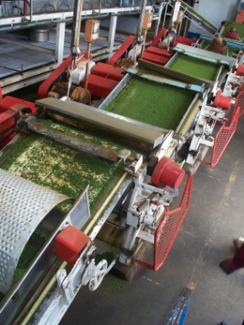
The initial process takes place when the leaves can either be handpicked or mechanically picked. There are benefits for both methods and cost for both too. Mainly while hand picking allows for a quicker regenerate of the tea plant this method yield as much smaller overall yield in an entire year. Hand pickers have a lower yield rate than the mechanical tea harvester but it is an expense that is easily absorbed by low labor costs. Although the plantation was expanding upon the idea of eliminating manual labor and switching to a machine ran by two people. If a machine was implemented for the manual labor they would yield almost twice as much of an ending year yield. One machine would replace twenty-five laborers. While this would seem to help their income the overall benefits are limited because the labor is so much cheaper the net revenues would be a little less than with the laborer. Also the image the plantation would gain if they laid off even part of the 13-14 thousand labor workers would create a very negative imagine. This could possibly result in a decrease in sales locally and internationally because of their harsh decision.
The process of after the initial picking was a fermentation process that turned green tea into black tea. The tea leaves must go through an extended drying session. They are dried from an 80% water capacity in the field to 70%. To do this they spread the leaves over large screens, air is then blown up through the leaves. When the leaves reach the necessary 70% moisture they enter the fermenting stage. The leaves are ground into small specs in order to release the caffeine from the leaves through oxidization. They then continue on a coverer belt for 140 minutes to complete the process from green tea to black tea. If green tea is desired there is a slightly different process. The green leaves would be chopped into small flakes that preserve most of the cells which eliminates a lot of the oxidation. Instead of oxidation creating the caffeine they are soaked in hot water that releases the alkaloids at a much slower rate with causes green tea to have a reduced amount of caffeine. After the fermenting period the ground tea is then dried down to approximately 3% moisture. This is done by forcing dry hot air into a large vat. To achieve this they use the eucalyptus trees as firewood that heats the air. After this the particle sizes are separated they are bagged and auctioned off to each different tea packing facility. The larger size particles are used for loose teas that are often sent to the Middle East; the middle sized grains are blended with smaller and larger particles and then shipped to England. The smaller particles are sent to the United States for instant tea.
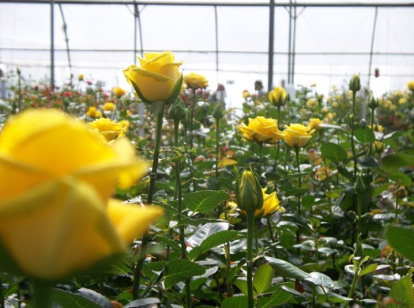
When the ground tea reaches a tea packing plant each tea is taste tested to determine where it will be used. The tea is mixed according to each individual preference. They taste test, store, mix, package and ship all from the same building. The plant we went to used teas from different parts of Kenya to create their unique needs, taste, and color. This was largely a consumer demand market only.
We had the opportunity to go and observe a cut flower farm, one that produces and export around the world but mainly to Europe. Here on average per day there are 400,000 roses picked and exported. The location for the flower farm creates a great atmosphere for their growth. They grow the roses in large green house to help manage and stabilize this atmosphere year round. They are expanding their efficiency of the water used because of the constant shortage and limitation that water has for farming in Africa. They collect as much of the excess water from the plants in trays. This water is then piped to a filter; they filter out the unused fertilizers while leaving the nutrients in the water. The water is forced through millions of small tubes that slowly filter out the fertilizers. This is a valuable process, the reuse of water because the water they use comes from Lake Naivasha which also supplies water to almost all the farmers around Nairobi. This is a growing concern for many people in Kenya because the supply of fresh water is diminishing more rapidly than they had previously anticipated. The need to find a solution to this problem is becoming a greater necessity with each passing day.
There were plenty of fun and excited experiences intertwined into the learning portion of this trip but I think that two of the most excited of these fun aspects was the hike into Hell’s Gate National Park and the Maasai Mara National Park.
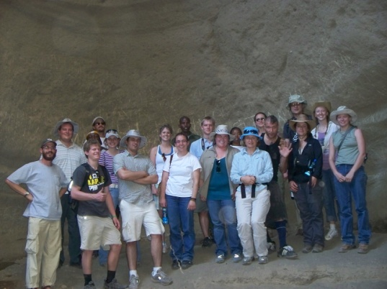
To begin Hell’s Gate was a hike down through the national park to observe the changing environment and dangers the park is facing. As a national park they strive to preserve the natural wildlife. This entails making sure the environment is not compromised due to climate change, the degradation of the habitat, growing surround populations, and changing land issues. The change in climate is causing dryer and dryer years. The dryer years causes there to be less vegetation for the grazing animals. The limited food supply drives these animals to migrate to different areas to seek provisions. With the growth population of people in the area it is beginning to encroach upon the area for which the animals can migrate. This population growth is also affecting the amount of water that is available to provide to the animal because it is needed for the agricultural side of the country.
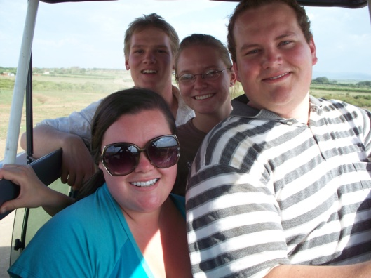
The Maasari Mara National Park is embracing the same ideals as Hell’s Gate. They are both sites of interest for tourist but still they are looking to preserve the way of life for all living things in Kenya. The Maasari Mara is looking to try and keep the Maasai people in somewhat of their natural environment. As a semi nomadic group, these cattle producers are know not for their cattle but for their intense cultural traditions. They are considered fierce warriors that consider hunting a lion as a fun and a sort of passage of each individual warrior. Among this several other traditions the people are only one of the aspects of the Maasari Mara that is being protected. The animals of the Safari are in many cases protected animals. There have been precautions taken to ensure that the animals are not driven or eliminated from this sacred area in Africa. I feel like this trip was a excellent way for not only me as an Agricultural Business major but also for the other majors that were along for the trip to really get a grasp of the drastic difference between our current economic and agricultural status. This is one of the many reason that as a growing society we need to be conscious of the worldwide picture and hope that all people in the world are rational, as according to most economic thought processes.

